|  |  |
| --- | --- |
| Nama | : La Ode Muhammad Gazali |
| NIM | : 222212696 |
| Kelas | : 2KS2 |

**TUGAS PRA PERTEMUAN 10**

**PRAKTIKUM PEMROGRAMAN BERORIENTASI OBJEK**

**Penugasan**

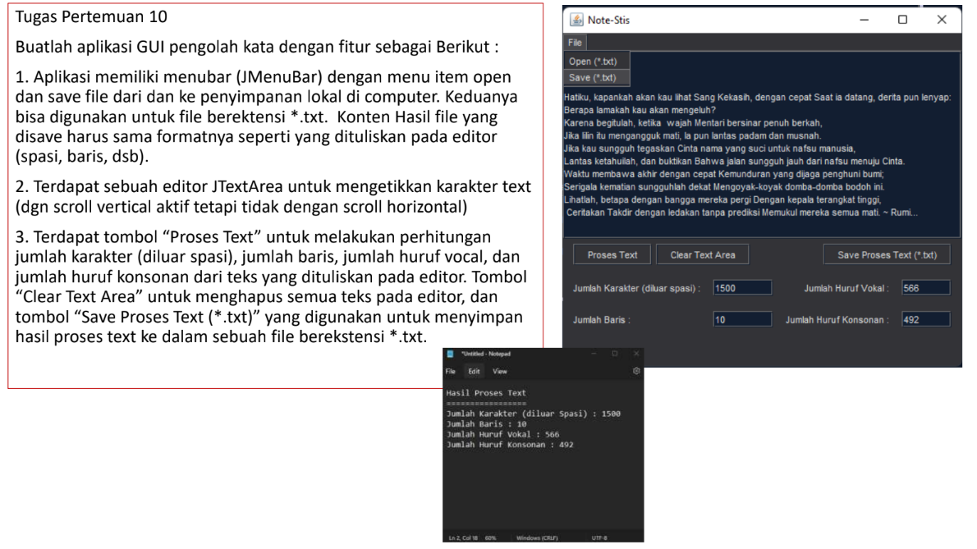

**Penyelesaian:**

**NoteStis.java**

/*

 * Click nbfs://nbhost/SystemFileSystem/Templates/Licenses/license-default.txt to change this license

 * Click nbfs://nbhost/SystemFileSystem/Templates/GUIForms/JFrame.java to edit this template

 */

package prapertemuan10;

/**

 *

 * @author U53R

 */

import java.awt.event.ActionEvent;

import java.awt.event.ActionListener;

import java.io.BufferedReader;

import java.io.BufferedWriter;

import java.io.File;

import java.io.FileReader;

import java.io.FileWriter;

import java.io.IOException;

import javax.swing.JFileChooser;

import javax.swing.JOptionPane;

import javax.swing.filechooser.FileNameExtensionFilter;

public class NoteStis2 extends javax.swing.JFrame {

    /**

     * Creates new form NoteStis2

     */

    Integer charCount;

    Integer countConsonant;

    Integer countVocal;

    Integer jumlahBaris;

    private JFileChooser fileChooser = new JFileChooser();

    public NoteStis2() {

        initComponents();

    }

    /**

     * This method is called from within the constructor to initialize the form.

     * WARNING: Do NOT modify this code. The content of this method is always

     * regenerated by the Form Editor.

     */

    @SuppressWarnings("unchecked")

    // <editor-fold defaultstate="collapsed" desc="Generated Code">//GEN-BEGIN:initComponents

    private void initComponents() {

        jPanel1 = new javax.swing.JPanel();

        jScrollPane1 = new javax.swing.JScrollPane();

        textArea = new javax.swing.JTextArea();

        prosesButton = new javax.swing.JButton();

        clearButton = new javax.swing.JButton();

        saveProsesButton = new javax.swing.JButton();

        jLabel1 = new javax.swing.JLabel();

        jLabel2 = new javax.swing.JLabel();

        jumKarakterTextField = new javax.swing.JTextField();

        jumBarisTextField = new javax.swing.JTextField();

        jLabel3 = new javax.swing.JLabel();

        jLabel4 = new javax.swing.JLabel();

        vokalTextField = new javax.swing.JTextField();

        konsonanTextField = new javax.swing.JTextField();

        jMenuBar1 = new javax.swing.JMenuBar();

        filejMenu = new javax.swing.JMenu();

        openMenuItem = new javax.swing.JMenuItem();

        saveMenuItem = new javax.swing.JMenuItem();

        setDefaultCloseOperation(javax.swing.WindowConstants.EXIT_ON_CLOSE);

        setBackground(new java.awt.Color(255, 153, 153));

        jPanel1.setBackground(new java.awt.Color(51, 51, 51));

        textArea.setBackground(new java.awt.Color(0, 0, 51));

        textArea.setColumns(20);

        textArea.setForeground(new java.awt.Color(255, 255, 255));

        textArea.setRows(5);

        jScrollPane1.setViewportView(textArea);

        prosesButton.setBackground(new java.awt.Color(51, 51, 51));

        prosesButton.setForeground(new java.awt.Color(255, 255, 255));

        prosesButton.setText("Proses Text");

        prosesButton.addActionListener(new java.awt.event.ActionListener() {

            public void actionPerformed(java.awt.event.ActionEvent evt) {

                prosesButtonActionPerformed(evt);

            }

        });

        clearButton.setBackground(new java.awt.Color(51, 51, 51));

        clearButton.setForeground(new java.awt.Color(255, 255, 255));

        clearButton.setText("Clear Text Area");

        clearButton.addActionListener(new java.awt.event.ActionListener() {

            public void actionPerformed(java.awt.event.ActionEvent evt) {

                clearButtonActionPerformed(evt);

            }

        });

        saveProsesButton.setBackground(new java.awt.Color(51, 51, 51));

        saveProsesButton.setForeground(new java.awt.Color(255, 255, 255));

        saveProsesButton.setText(" Save Proses Text (*.txt)");

        saveProsesButton.addActionListener(new java.awt.event.ActionListener() {

            public void actionPerformed(java.awt.event.ActionEvent evt) {

                saveProsesButtonActionPerformed(evt);

            }

        });

        jLabel1.setForeground(new java.awt.Color(255, 255, 255));

        jLabel1.setText("Jumlah Karakter (diluar spasi) :");

        jLabel2.setForeground(new java.awt.Color(255, 255, 255));

        jLabel2.setText("Jumlah Baris :");

        jumKarakterTextField.setBackground(new java.awt.Color(0, 0, 51));

        jumKarakterTextField.setForeground(new java.awt.Color(255, 255, 255));

        jumKarakterTextField.addActionListener(new java.awt.event.ActionListener() {

            public void actionPerformed(java.awt.event.ActionEvent evt) {

                jumKarakterTextFieldActionPerformed(evt);

            }

        });

        jumBarisTextField.setBackground(new java.awt.Color(0, 0, 51));

        jumBarisTextField.setForeground(new java.awt.Color(255, 255, 255));

        jumBarisTextField.addActionListener(new java.awt.event.ActionListener() {

            public void actionPerformed(java.awt.event.ActionEvent evt) {

                jumBarisTextFieldActionPerformed(evt);

            }

        });

        jLabel3.setForeground(new java.awt.Color(255, 255, 255));

        jLabel3.setText("Jumlah Huruf Konsonan :");

        jLabel4.setForeground(new java.awt.Color(255, 255, 255));

        jLabel4.setText("Jumlah Huruf Vokal :");

        vokalTextField.setBackground(new java.awt.Color(0, 0, 51));

        vokalTextField.setForeground(new java.awt.Color(255, 255, 255));

        vokalTextField.addActionListener(new java.awt.event.ActionListener() {

            public void actionPerformed(java.awt.event.ActionEvent evt) {

                vokalTextFieldActionPerformed(evt);

            }

        });

        konsonanTextField.setBackground(new java.awt.Color(0, 0, 51));

        konsonanTextField.setForeground(new java.awt.Color(255, 255, 255));

        konsonanTextField.addActionListener(new java.awt.event.ActionListener() {

            public void actionPerformed(java.awt.event.ActionEvent evt) {

                konsonanTextFieldActionPerformed(evt);

            }

        });

        javax.swing.GroupLayout jPanel1Layout = new javax.swing.GroupLayout(jPanel1);

        jPanel1.setLayout(jPanel1Layout);

        jPanel1Layout.setHorizontalGroup(

            jPanel1Layout.createParallelGroup(javax.swing.GroupLayout.Alignment.LEADING)

            .addComponent(jScrollPane1, javax.swing.GroupLayout.DEFAULT_SIZE, 530, Short.MAX_VALUE)

            .addGroup(javax.swing.GroupLayout.Alignment.TRAILING, jPanel1Layout.createSequentialGroup()

                .addContainerGap(javax.swing.GroupLayout.DEFAULT_SIZE, Short.MAX_VALUE)

                .addComponent(saveProsesButton)

                .addGap(34, 34, 34))

            .addGroup(jPanel1Layout.createParallelGroup(javax.swing.GroupLayout.Alignment.LEADING)

                .addGroup(jPanel1Layout.createSequentialGroup()

                    .addContainerGap()

                    .addGroup(jPanel1Layout.createParallelGroup(javax.swing.GroupLayout.Alignment.LEADING)

                        .addGroup(jPanel1Layout.createSequentialGroup()

                            .addGap(11, 11, 11)

                            .addComponent(prosesButton)

                            .addPreferredGap(javax.swing.LayoutStyle.ComponentPlacement.UNRELATED)

                            .addComponent(clearButton, javax.swing.GroupLayout.PREFERRED_SIZE, 119, javax.swing.GroupLayout.PREFERRED_SIZE))

                        .addGroup(jPanel1Layout.createSequentialGroup()

                            .addGroup(jPanel1Layout.createParallelGroup(javax.swing.GroupLayout.Alignment.LEADING, false)

                                .addGroup(jPanel1Layout.createSequentialGroup()

                                    .addComponent(jLabel1)

                                    .addPreferredGap(javax.swing.LayoutStyle.ComponentPlacement.RELATED)

                                    .addComponent(jumKarakterTextField, javax.swing.GroupLayout.PREFERRED_SIZE, 71, javax.swing.GroupLayout.PREFERRED_SIZE))

                                .addGroup(jPanel1Layout.createSequentialGroup()

                                    .addComponent(jLabel2)

                                    .addPreferredGap(javax.swing.LayoutStyle.ComponentPlacement.RELATED, javax.swing.GroupLayout.DEFAULT_SIZE, Short.MAX_VALUE)

                                    .addComponent(jumBarisTextField, javax.swing.GroupLayout.PREFERRED_SIZE, 71, javax.swing.GroupLayout.PREFERRED_SIZE)))

                            .addGap(38, 38, 38)

                            .addGroup(jPanel1Layout.createParallelGroup(javax.swing.GroupLayout.Alignment.TRAILING)

                                .addComponent(jLabel4)

                                .addComponent(jLabel3))

                            .addPreferredGap(javax.swing.LayoutStyle.ComponentPlacement.UNRELATED)

                            .addGroup(jPanel1Layout.createParallelGroup(javax.swing.GroupLayout.Alignment.LEADING)

                                .addComponent(vokalTextField, javax.swing.GroupLayout.PREFERRED_SIZE, 71, javax.swing.GroupLayout.PREFERRED_SIZE)

                                .addComponent(konsonanTextField, javax.swing.GroupLayout.PREFERRED_SIZE, 71, javax.swing.GroupLayout.PREFERRED_SIZE))))

                    .addContainerGap(28, Short.MAX_VALUE)))

        );

        jPanel1Layout.setVerticalGroup(

            jPanel1Layout.createParallelGroup(javax.swing.GroupLayout.Alignment.LEADING)

            .addGroup(javax.swing.GroupLayout.Alignment.TRAILING, jPanel1Layout.createSequentialGroup()

                .addComponent(jScrollPane1, javax.swing.GroupLayout.PREFERRED_SIZE, 205, javax.swing.GroupLayout.PREFERRED_SIZE)

                .addPreferredGap(javax.swing.LayoutStyle.ComponentPlacement.UNRELATED)

                .addComponent(saveProsesButton)

                .addContainerGap(138, Short.MAX_VALUE))

            .addGroup(jPanel1Layout.createParallelGroup(javax.swing.GroupLayout.Alignment.LEADING)

                .addGroup(jPanel1Layout.createSequentialGroup()

                    .addGap(216, 216, 216)

                    .addGroup(jPanel1Layout.createParallelGroup(javax.swing.GroupLayout.Alignment.BASELINE)

                        .addComponent(prosesButton)

                        .addComponent(clearButton))

                    .addGap(18, 18, 18)

                    .addGroup(jPanel1Layout.createParallelGroup(javax.swing.GroupLayout.Alignment.BASELINE)

                        .addComponent(jLabel1)

                        .addComponent(jumKarakterTextField, javax.swing.GroupLayout.PREFERRED_SIZE, javax.swing.GroupLayout.DEFAULT_SIZE, javax.swing.GroupLayout.PREFERRED_SIZE)

                        .addComponent(jLabel4)

                        .addComponent(vokalTextField, javax.swing.GroupLayout.PREFERRED_SIZE, javax.swing.GroupLayout.DEFAULT_SIZE, javax.swing.GroupLayout.PREFERRED_SIZE))

                    .addGap(22, 22, 22)

                    .addGroup(jPanel1Layout.createParallelGroup(javax.swing.GroupLayout.Alignment.BASELINE)

                        .addComponent(jLabel2)

                        .addComponent(jumBarisTextField, javax.swing.GroupLayout.PREFERRED_SIZE, javax.swing.GroupLayout.DEFAULT_SIZE, javax.swing.GroupLayout.PREFERRED_SIZE)

                        .addComponent(jLabel3)

                        .addComponent(konsonanTextField, javax.swing.GroupLayout.PREFERRED_SIZE, javax.swing.GroupLayout.DEFAULT_SIZE, javax.swing.GroupLayout.PREFERRED_SIZE))

                    .addContainerGap(32, Short.MAX_VALUE)))

        );

        jMenuBar1.setBackground(new java.awt.Color(153, 255, 153));

        jMenuBar1.setForeground(new java.awt.Color(51, 51, 51));

        filejMenu.setBackground(new java.awt.Color(51, 51, 51));

        filejMenu.setForeground(new java.awt.Color(255, 255, 255));

        filejMenu.setText("File");

        openMenuItem.setBackground(new java.awt.Color(51, 51, 51));

        openMenuItem.setText("Open (*.txt)");

        openMenuItem.addActionListener(new java.awt.event.ActionListener() {

            public void actionPerformed(java.awt.event.ActionEvent evt) {

                openMenuItemActionPerformed(evt);

            }

        });

        filejMenu.add(openMenuItem);

        saveMenuItem.setText("Save (*.txt)");

        saveMenuItem.addActionListener(new java.awt.event.ActionListener() {

            public void actionPerformed(java.awt.event.ActionEvent evt) {

                saveMenuItemActionPerformed(evt);

            }

        });

        filejMenu.add(saveMenuItem);

        jMenuBar1.add(filejMenu);

        setJMenuBar(jMenuBar1);

        javax.swing.GroupLayout layout = new javax.swing.GroupLayout(getContentPane());

        getContentPane().setLayout(layout);

        layout.setHorizontalGroup(

            layout.createParallelGroup(javax.swing.GroupLayout.Alignment.LEADING)

            .addComponent(jPanel1, javax.swing.GroupLayout.DEFAULT_SIZE, javax.swing.GroupLayout.DEFAULT_SIZE, Short.MAX_VALUE)

        );

        layout.setVerticalGroup(

            layout.createParallelGroup(javax.swing.GroupLayout.Alignment.LEADING)

            .addGroup(layout.createSequentialGroup()

                .addContainerGap()

                .addComponent(jPanel1, javax.swing.GroupLayout.DEFAULT_SIZE, javax.swing.GroupLayout.DEFAULT_SIZE, Short.MAX_VALUE))

        );

        pack();

    }// </editor-fold>//GEN-END:initComponents

    private void openFile() {

        int returnVal = fileChooser.showOpenDialog(this);

        if (returnVal == JFileChooser.APPROVE_OPTION) {

            File file = fileChooser.getSelectedFile();

            try (BufferedReader reader = new BufferedReader(new FileReader(file))) {

                String line;

                StringBuilder text = new StringBuilder();

                while ((line = reader.readLine()) != null) {

                    text.append(line).append("\n");

                }

                textArea.setText(text.toString());

            } catch (IOException e) {

                e.printStackTrace();

            }

        }

    }

    private void saveFile() {

        int returnValue = fileChooser.showOpenDialog(this);

        if (returnValue == JFileChooser.APPROVE_OPTION) {

            File file = fileChooser.getSelectedFile();

            String filePath = file.getAbsolutePath();

            if (!filePath.endsWith(".txt")) {

                filePath += ".txt";

            }

            try {

                BufferedWriter writer = new BufferedWriter(new FileWriter(filePath));

                writer.write(textArea.getText());

                JOptionPane.showMessageDialog(null,"Save File Succes");

                writer.close();

            } catch (IOException e) {

                JOptionPane.showMessageDialog(null,"Save File Failed");

                e.printStackTrace();

            }

        }

    }

    private void saveTextProcess() {

        int returnValue = fileChooser.showOpenDialog(this);

        if (returnValue == JFileChooser.APPROVE_OPTION) {

            File file = fileChooser.getSelectedFile();

            String filePath = file.getAbsolutePath();

            if (!filePath.endsWith(".txt")) {

                filePath += ".txt";

            }

            try (BufferedWriter writer = new BufferedWriter(new FileWriter(filePath))) {

                writer.write("Hasil proses text: ");

                writer.newLine();

                writer.write("Jumlah Karakter (diluar spasi): " + jumKarakterTextField.getText());

                writer.newLine();

                writer.write("Jumlah baris: " + jumBarisTextField.getText());

                writer.newLine();

                writer.write("Jumlah Huruf Vokal: " + vokalTextField.getText());

                writer.newLine();

                writer.write("Jumlah Huruf Konsonan: " + konsonanTextField.getText());

                JOptionPane.showMessageDialog(null, "Save Process File Succes");

            } catch (IOException e) {

                JOptionPane.showMessageDialog(null, "Save Process File Failed");

                e.printStackTrace();

            }

        }

    }

    private void saveMenuItemActionPerformed(java.awt.event.ActionEvent evt) {//GEN-FIRST:event_saveMenuItemActionPerformed

        saveFile();

    }//GEN-LAST:event_saveMenuItemActionPerformed

    private void prosesButtonActionPerformed(java.awt.event.ActionEvent evt) {//GEN-FIRST:event_prosesButtonActionPerformed

        // TODO add your handling code here:

        String fullText = textArea.getText().replace(" ", "");

        // Split the text into lines and initialize counters

        String[] lineText = fullText.split("\n");

        jumlahBaris = 0; charCount = 0;

        jumlahBaris = lineText.length;

        // Loop through each line and count characters

        for (String textLine : lineText) {

            charCount += textLine.length();

        }

        // Update the text fields with the number of lines and characters

        jumBarisTextField.setText(jumlahBaris.toString());

        jumKarakterTextField.setText(charCount.toString());

        // Initialize consonant and vowel counters and convert the text to lowercase

        countConsonant = 0; countVocal = 0;

        String lowercaseText = fullText.toLowerCase();

        // Loop through each character in the lowercase text

        for (int i = 0; i < lowercaseText.length(); i++) {

            char letter = lowercaseText.charAt(i);

            // If the character is a letter, check if it's a consonant or vowel

            if (letter >= 'a' && letter <= 'z') {

                if (letter != 'a' && letter != 'i' && letter != 'u' && letter != 'e' && letter != '0') {

                    countConsonant++;

                } else {

                    countVocal++;

                }

            }

        }

        // Update the text fields with the number of consonants and vowels

        konsonanTextField.setText(countConsonant.toString());

        vokalTextField.setText(countVocal.toString());

    }//GEN-LAST:event_prosesButtonActionPerformed

    private void saveProsesButtonActionPerformed(java.awt.event.ActionEvent evt) {//GEN-FIRST:event_saveProsesButtonActionPerformed

        // TODO add your handling code here:

        saveTextProcess();

    }//GEN-LAST:event_saveProsesButtonActionPerformed

    private void jumKarakterTextFieldActionPerformed(java.awt.event.ActionEvent evt) {//GEN-FIRST:event_jumKarakterTextFieldActionPerformed

        // TODO add your handling code here:

    }//GEN-LAST:event_jumKarakterTextFieldActionPerformed

    private void vokalTextFieldActionPerformed(java.awt.event.ActionEvent evt) {//GEN-FIRST:event_vokalTextFieldActionPerformed

        // TODO add your handling code here:

    }//GEN-LAST:event_vokalTextFieldActionPerformed

    private void clearButtonActionPerformed(java.awt.event.ActionEvent evt) {//GEN-FIRST:event_clearButtonActionPerformed

        // TODO add your handling code here:

            // Clear the text area and reset all counters

        textArea.setText("");

        countConsonant = 0;

        countVocal = 0;

        jumlahBaris = 0;

        charCount = 0;

        jumBarisTextField.setText("0");

        konsonanTextField.setText("0");

        vokalTextField.setText("0");

        jumKarakterTextField.setText("0");

    }//GEN-LAST:event_clearButtonActionPerformed

    private void konsonanTextFieldActionPerformed(java.awt.event.ActionEvent evt) {//GEN-FIRST:event_konsonanTextFieldActionPerformed

        // TODO add your handling code here:

    }//GEN-LAST:event_konsonanTextFieldActionPerformed

    private void jumBarisTextFieldActionPerformed(java.awt.event.ActionEvent evt) {//GEN-FIRST:event_jumBarisTextFieldActionPerformed

        // TODO add your handling code here:

    }//GEN-LAST:event_jumBarisTextFieldActionPerformed

    private void openMenuItemActionPerformed(java.awt.event.ActionEvent evt) {//GEN-FIRST:event_openMenuItemActionPerformed

        // TODO add your handling code here:

        openFile();

    }//GEN-LAST:event_openMenuItemActionPerformed

    /**

     * @param args the command line arguments

     */

    public static void main(String args[]) {

        /* Set the Nimbus look and feel */

        //<editor-fold defaultstate="collapsed" desc=" Look and feel setting code (optional) ">

        /* If Nimbus (introduced in Java SE 6) is not available, stay with the default look and feel.

         * For details see http://download.oracle.com/javase/tutorial/uiswing/lookandfeel/plaf.html

         */

        try {

            for (javax.swing.UIManager.LookAndFeelInfo info : javax.swing.UIManager.getInstalledLookAndFeels()) {

                if ("Nimbus".equals(info.getName())) {

                    javax.swing.UIManager.setLookAndFeel(info.getClassName());

                    break;

                }

            }

        } catch (ClassNotFoundException ex) {

            java.util.logging.Logger.getLogger(NoteStis2.class.getName()).log(java.util.logging.Level.SEVERE, null, ex);

        } catch (InstantiationException ex) {

            java.util.logging.Logger.getLogger(NoteStis2.class.getName()).log(java.util.logging.Level.SEVERE, null, ex);

        } catch (IllegalAccessException ex) {

            java.util.logging.Logger.getLogger(NoteStis2.class.getName()).log(java.util.logging.Level.SEVERE, null, ex);

        } catch (javax.swing.UnsupportedLookAndFeelException ex) {

            java.util.logging.Logger.getLogger(NoteStis2.class.getName()).log(java.util.logging.Level.SEVERE, null, ex);

        }

        //</editor-fold>

        /* Create and display the form */

        java.awt.EventQueue.invokeLater(new Runnable() {

            public void run() {

                new NoteStis2().setVisible(true);

            }

        });

    }

    // Variables declaration - do not modify//GEN-BEGIN:variables

    private javax.swing.JButton clearButton;

    private javax.swing.JMenu filejMenu;

    private javax.swing.JLabel jLabel1;

    private javax.swing.JLabel jLabel2;

    private javax.swing.JLabel jLabel3;

    private javax.swing.JLabel jLabel4;

    private javax.swing.JMenuBar jMenuBar1;

    private javax.swing.JPanel jPanel1;

    private javax.swing.JScrollPane jScrollPane1;

    private javax.swing.JTextField jumBarisTextField;

    private javax.swing.JTextField jumKarakterTextField;

    private javax.swing.JTextField konsonanTextField;

    private javax.swing.JMenuItem openMenuItem;

    private javax.swing.JButton prosesButton;

    private javax.swing.JMenuItem saveMenuItem;

    private javax.swing.JButton saveProsesButton;

    private javax.swing.JTextArea textArea;

    private javax.swing.JTextField vokalTextField;

    // End of variables declaration//GEN-END:variables

}

**Design JFrame**

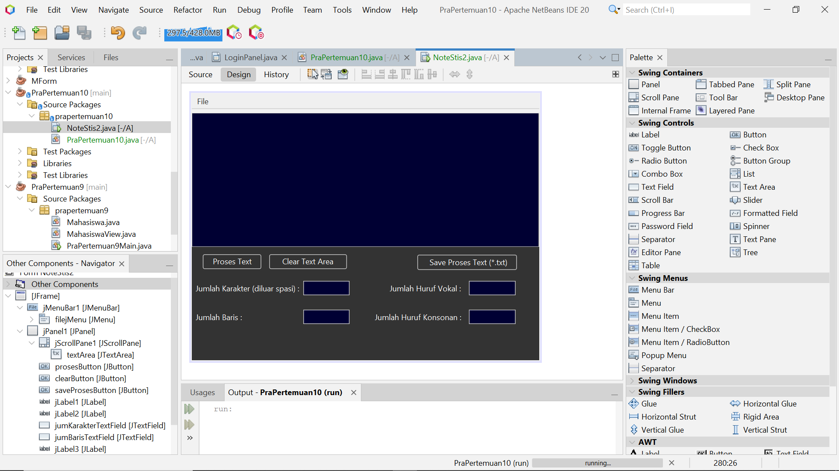

**Menjalankan tombol Proses Text**

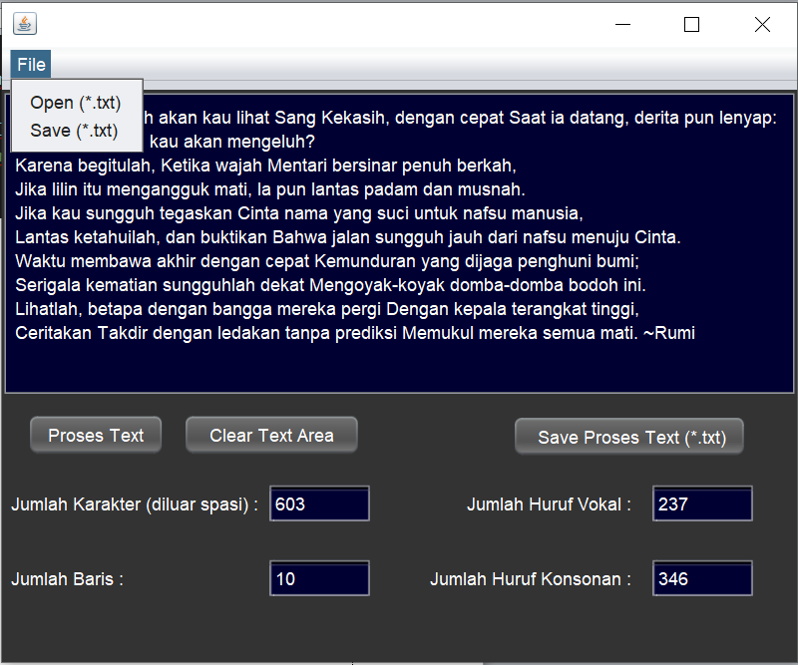

**Menjalankan tombol Save Proses Text**

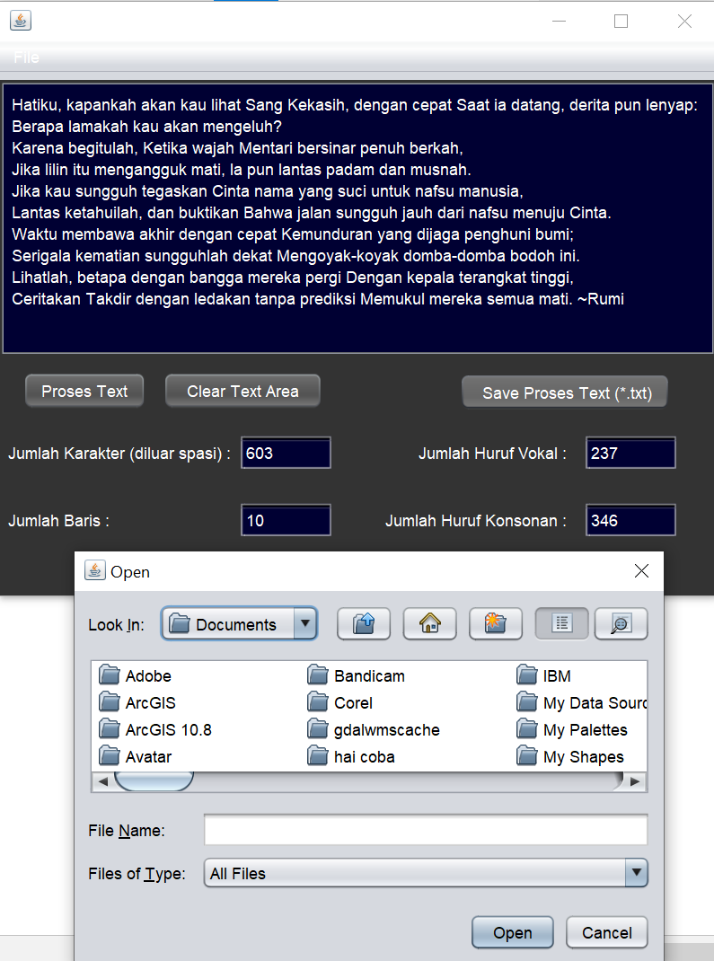

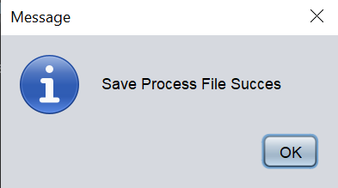

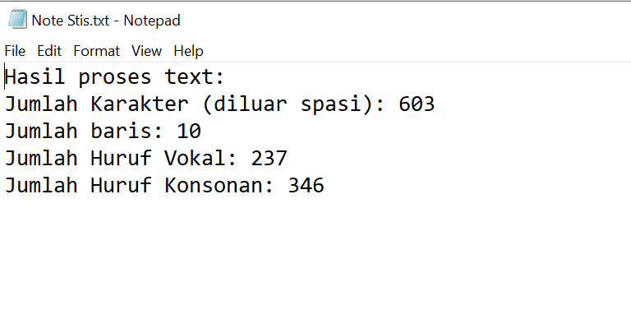

**Menjalankan tombol Clear Text Area**

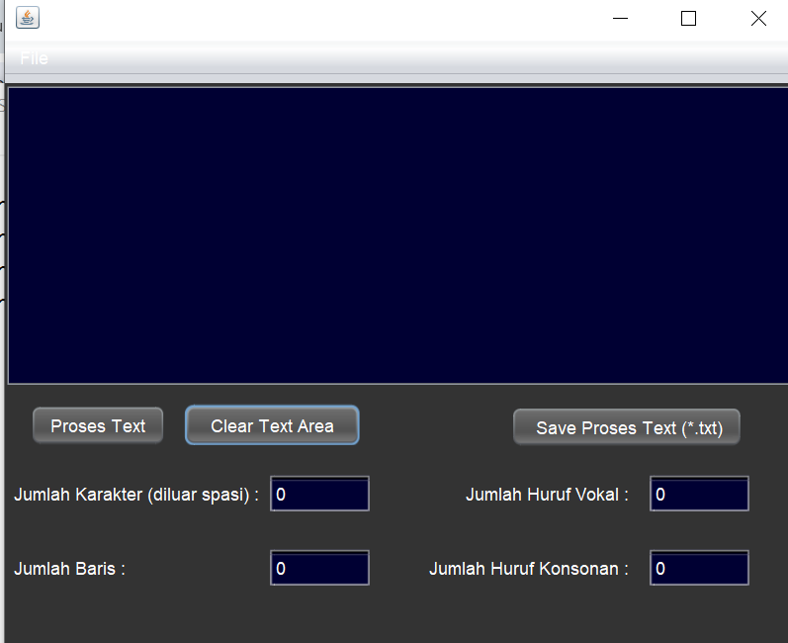

**Melakukan Open File Note STIS kembali**

